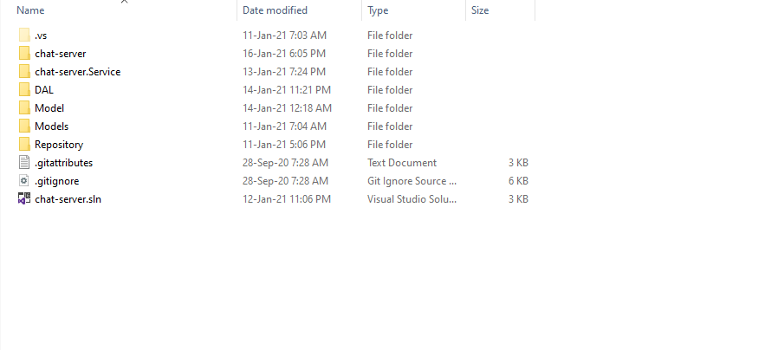How to open chat-server

Fig: open chat-server folder

Now you double click on *chat-server.sln*

After some time leter it open and ready to open

By pressing key *f5* you can open the IIS-Server